Second partner country of the month: USA
Another partner country of the University of Bayreuth is the United States of America. In the following, we will introduce you to what the "Land of Unlimited Possibilities" has to offer. In addition, you should get an idea of how you can spend your stay abroad in the USA. Depending on the study programme, the University of Bayreuth has a total of eleven partner universities in the USA to choose from. Below we will introduce you to Temple University and Weber State University. A detailed overview of all partner universities can be found here.

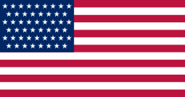
General facts and figures:
Capital: Washington D.C.
Population: approx. 331.5 million (as of 2020)
National holiday: 4 July (Independence Day)
Currency: US dollar ($)
Time zone: UTC-5 to UTC-10
Official language: English

USA
With a total area of 9.83 million km², the USA is the third largest country on Earth. Only Canada and Russia are larger. In terms of population, the US also ranks third in the world. Only China and India have more inhabitants. The US borders Canada to the north (total border length: 8,895 kilometers) and Mexico to the south (total border length: 3,326 kilometers). In addition, the United States of America is located on the Atlantic Ocean, Pacific Ocean, and the Gulf of Mexico. The northernmost city in the USA is Utqiaġvik in Alaska and the southernmost is Hawaiian Ocean View in Hawaii.
Due to the size of the US, the climatic conditions and landscapes vary considerably. It has mountain ranges (e.g. the Rocky Mountains), deserts (e.g. Great Basin Desert) and a variety of national forests.
In Europe, American cuisine is mainly known for fast food such as burgers, hotdogs, wings, etc. However, there are many differences depending on the region you’re visiting. Southern cuisine, for example, makes extended use of rice, corn, and poultry. In New England, dishes like baked beans or apple pie are popular.

Temple University
The city of Philadelphia is located in the state of Pennsylvania and is home to around 1.6 million inhabitants. This makes Philly the sixth largest city in the United States and the largest in the state of Pennsylvania. The city is located in the East Coast metropolitan area. New York City is about 90 km away, Washington D.C. 210 km away, and Atlantic City about 90 km away. In addition, the city is located between the Schuylkill and Delaware Rivers. The Delaware River represents Philadelphia's border with the state of New Jersey. One of the most famous sights of the city is the Liberty Bell, a symbol of independence. It was rung for the first time on 8 July 1776, after the independence of the USA had been decided on 4 July 1776 (also in Philadelphia). Another highlight of the city is the Philadelphia Museum of Art and the stairs leading to it, the so-called Rocky Steps. These got their name from the fact that the famous stair scene from the third Rocky movie was filmed here. Another highlight is South Street, which invites you to take a leisurely stroll with its many small shops and ends at Penn's Landing. Situated at the Delaware River, you can attend numerous attractions, concerts, or events. More sights of the city are available here.
Another culinary "landmark" of the city is the Philly Cheesesteak. This consists of very thinly sliced steak meat, which is briefly browned and then served with a lot of cheese in a wheat roll. Philadelphia is also represented in many different sports at the highest level. The city is home to the Philadelphia Union soccer team, the Philadelphia Flyers ice hockey team, the Philadelphia Phillies baseball team, the Philadelphia 76ers basketball team, and the Philadelphia Eagles football team. The locals here take their sports teams seriously, and after a winning game there is a euphoric mood in the city. In fact, after the Eagles' Super Bowl victory in 2018, the city was in a state of emergency.
In terms of transportation, the easiest way to get around Philadelphia is by subway (SEPTA).
Temple University had approximately 39,000 students in 2019/20. Additionally, the university has six different campuses within the city of Philadelphia, as well as two international campuses in Rome and Japan. At the university, it is possible to combine more than 500 different degree programmes and study at 15 colleges/faculties. These include the Fox School of Business, School of Sport, Tourism and Hospitality Management and the College of Public Health. The main campus is located in North Philadelphia, which does have poverty and an above-average crime rate. However, the campus itself is very safe, with more than 130 campus police officers (the highest number of university police officers in the entire U.S.) and several police stations. With a little experience and tact, there is nothing to worry about off campus.
Student life at Temple University is extremely diverse and varied. For example, you can meet
other like-minded people in a wide variety of clubs, such as the Soccer Club, Climbing Club, etc. In addition, the university has a variety of sports facilities, such as gyms, a climbing wall, indoor swimming pool, turf fields, etc., all of which can be used free of charge. Attending sports competitions of the university teams is also free of charge. For example, you can watch Division I basketball team games at the Liacouras Center or Division I football team games at Lincoln Field (the Philadelphia Eagles' stadium). In addition, the campus has a variety of dining halls and food trucks at which food can be purchased. Thus, there are varied options when it comes to food choices.
When looking for housing, you can live on-campus or off-campus. On-campus you can apply for a few student residences through the university. You can find an overview here. Off-campus there are often good options, which are often cheaper and still close to the university. For this I can recommend Sydenham-Commons, among others.
The semester times in the USA differ from Germany. The fall/winter semester lasts from August to December and the spring/summer semester from January to May. At some universities there is even a summer semester, which lasts from May to August.
If you want to get more information about Temple University, just have a look here or on their YouTube channel. You can also read some testimonials from former students here.
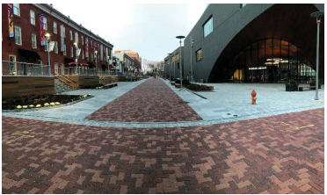
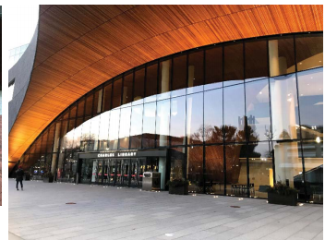
Temple University campus center
Charles Library
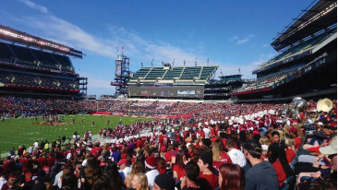
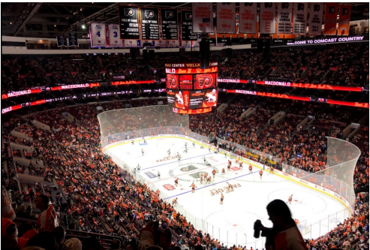
Home game of the Temple Owls
Philadelphia Flyers Owls home game

Weber State University
Weber State University is located in Ogden, Utah. The city is surrounded by the Wasatch Range (mountain range of the Rocky Mountains) and the Weber and Ogden Rivers. Sixteen kilometres away is Salt Lake and about sixty-four kilometres away is Salt Lake City. The city of Odgen is the seventh largest city in Utah with a population of 87,000. Due to its proximity to the Rocky Mountains, two large ski resorts (Snowbasin and Powder Mountain) are located here. In addition, the landscape features extensive running and hiking trails, mountain biking routes, and numerous climbing and bouldering trails. In addition to outdoor activities, Odgen has several attractions, such as Historic 25th Street. This is used as a background for numerous movies and series. There are also some museums, such as the Hill Aerospace Museum or the Utah State Railroad Museum. You can find an overview here.
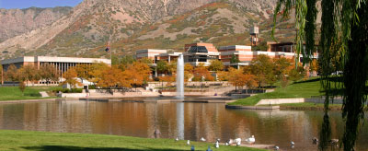
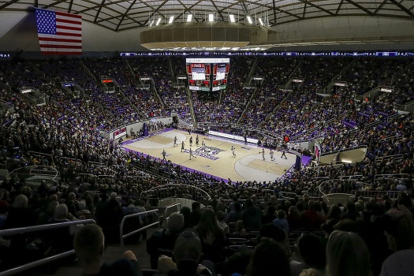
Weber State University is home to approximately 25,000 students, most of whom are from Utah. However, students from over 60 different countries study on Weber State’s campus. In addition to the main campus, the university has seven other campuses. The university is divided into seven departments/colleges. It has the Dee Events Center, which is the largest arena in Utah north of Salt Lake City with a seating capacity of 11,592. This is where the men's and women's basketball teams play their home games.
When looking for housing, you can get assistance from the university if you want to stay in a dormitory. There is the so-called Wildcats Village directly at the university and the University Village, a 20-minute walk from the university. You can also look for off-campus housing yourself. The Wildcats Village has a gym, volleyball court, lounges, barbecue areas, and much more. However, when you move in, you must purchase a Meal Plan to go with it. This is not mandatory at University Village.
As a student of the University of Bayreuth, you can do an exchange at Weber State University regardless of your major. This means that you can apply for a place abroad no matter what you study here in Bayreuth. Unlike Temple University, the academic year is divided into trimesters.
If you want to get more information about Weber State University, just have a look here or on their YouTube channel. You can also read some testimonials from former students here.
Have we sparked your interest in an exchange to the USA? Then take a look at all the information about the universities in our Publisher and find out about your options. Financial support can be obtained through the PROMOS programme of the DAAD. Here is a detailed explanation. In addition, for a semester abroad in the USA you usually have to take a TOEFEL test. You can also get detailed information about the requirements from the publisher.
WU campus in Ogden
Home game of the Weber State Wildcats

The application deadline for going abroad the following year is 1 December for students enrolled in bachelor's and master's programmes.

https://www.deseret.com/2017/7/7/20615420/weber-state-announces-2017-18-men-s-basketball-schedule
https://www.weber.edu/AboutWSU/Locations.html

