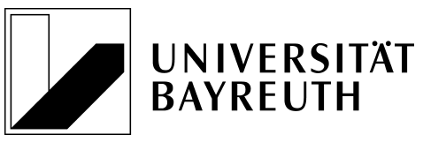

Wählen Sie ein Element aus.

Degree Certificate

Mr. Max Mustermann

born in Munich on 14 March 1991

successfully completed the

Master’s Programme
PHYSICS
with a final grade of
Wählen Sie ein Element aus. (1,0)
on 31 March 2014.

Individual grades are listed on the following page.

Bayreuth, 10 June 2014

Chair of Examiners

[signature illegible]

Prof. Dr. XY

END OF TRANSLATION

